Cryptography Homework

|  |  |  |  |
| --- | --- | --- | --- |
| **Riddle** | **Answer** | **Key** | **Solution** |
| 1 | gruber | 6skd8s | https://www.dcode.fr/caesar-cipher |
| 2 | gennero | cy8snd2 | Rapid tables Binary to ASCII |
| 3 | takagi | ud6s98n | openssl enc -d -pbkdf2 -nosalt -aes-256-cbc -in cipher.txt -base64 -K 5284A3B154D99487D9D8D8508461A478C7BEB67081A64AD9A15147906E8E8564 -iv 1907C5E255F7FC9A6B47B0E789847AED -out dec.txt |
| 4 |  | 7gsn3nd2 |  |
| 5 | argyle | ajy39d2 | hashcat -m 0 -a 0 -o cracked1.txt hashed.txt /usr/share/wordlists/rockyou.txt --force --potfile-disable |
| 6 | mcclane | 7skahd6 | ./steghide.exe extract -sf mary-lamb.jpg |

Ransomware Decrypter

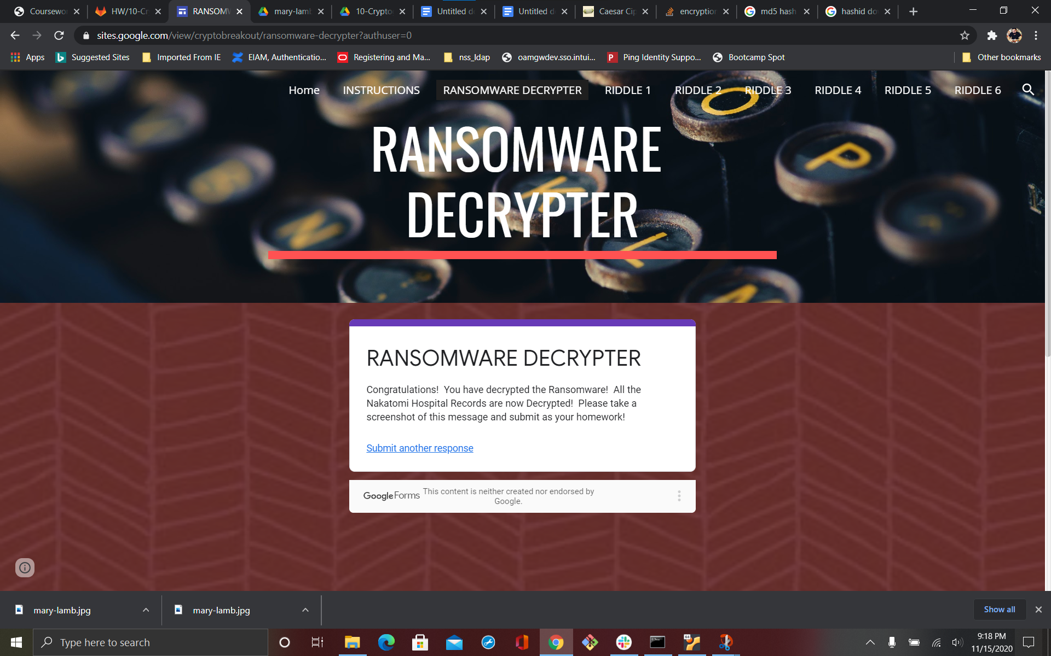

Riddle 1

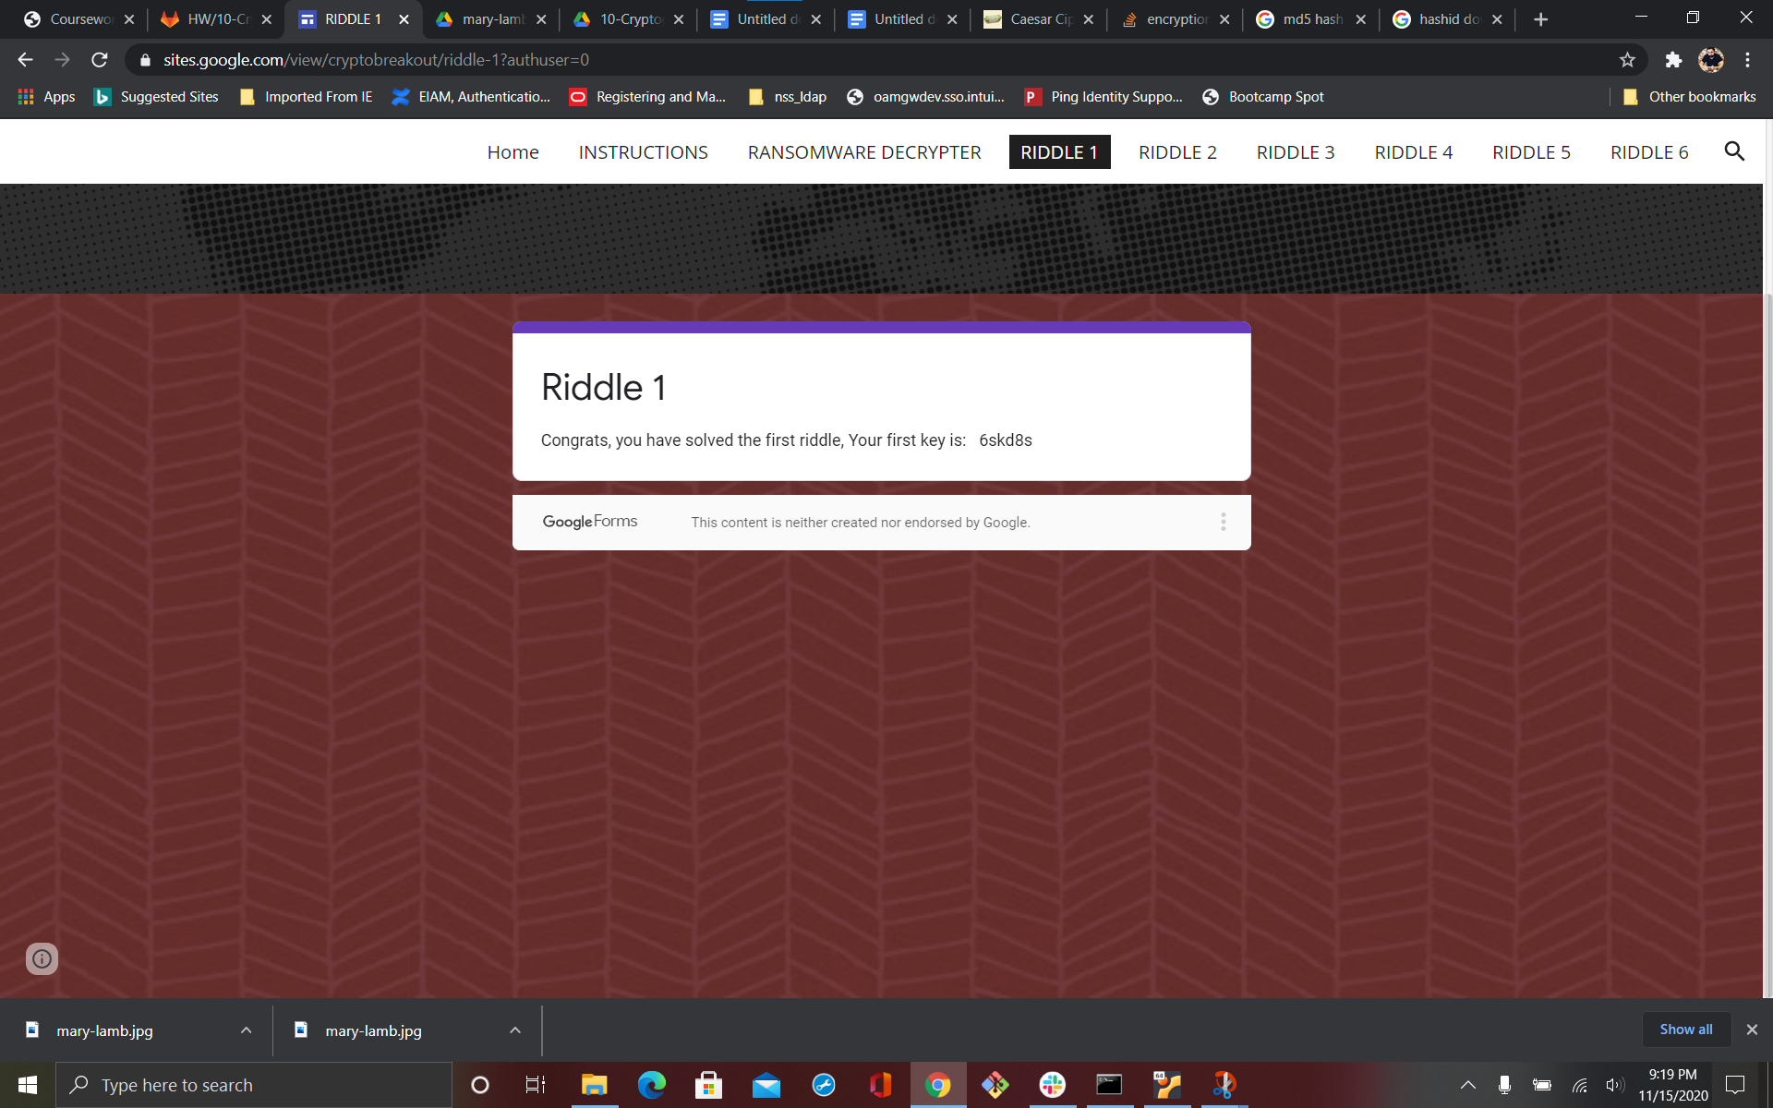

Riddle 2

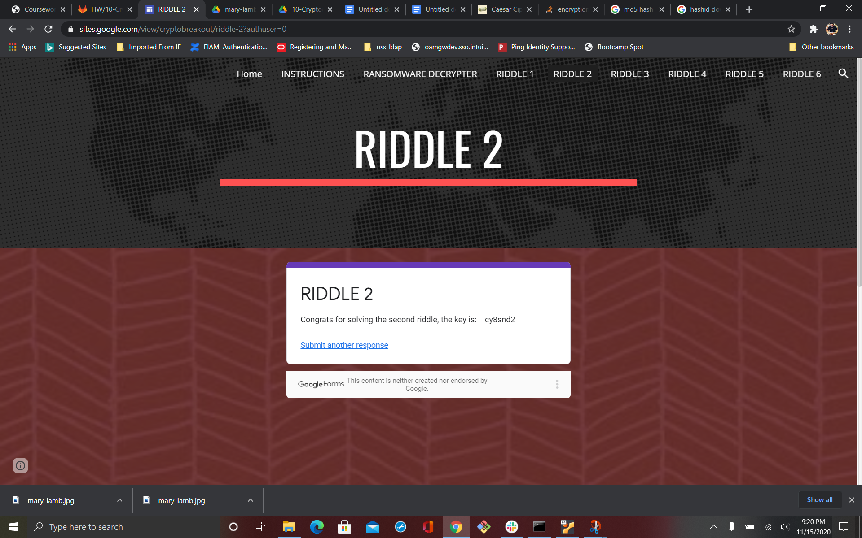

Riddle 3

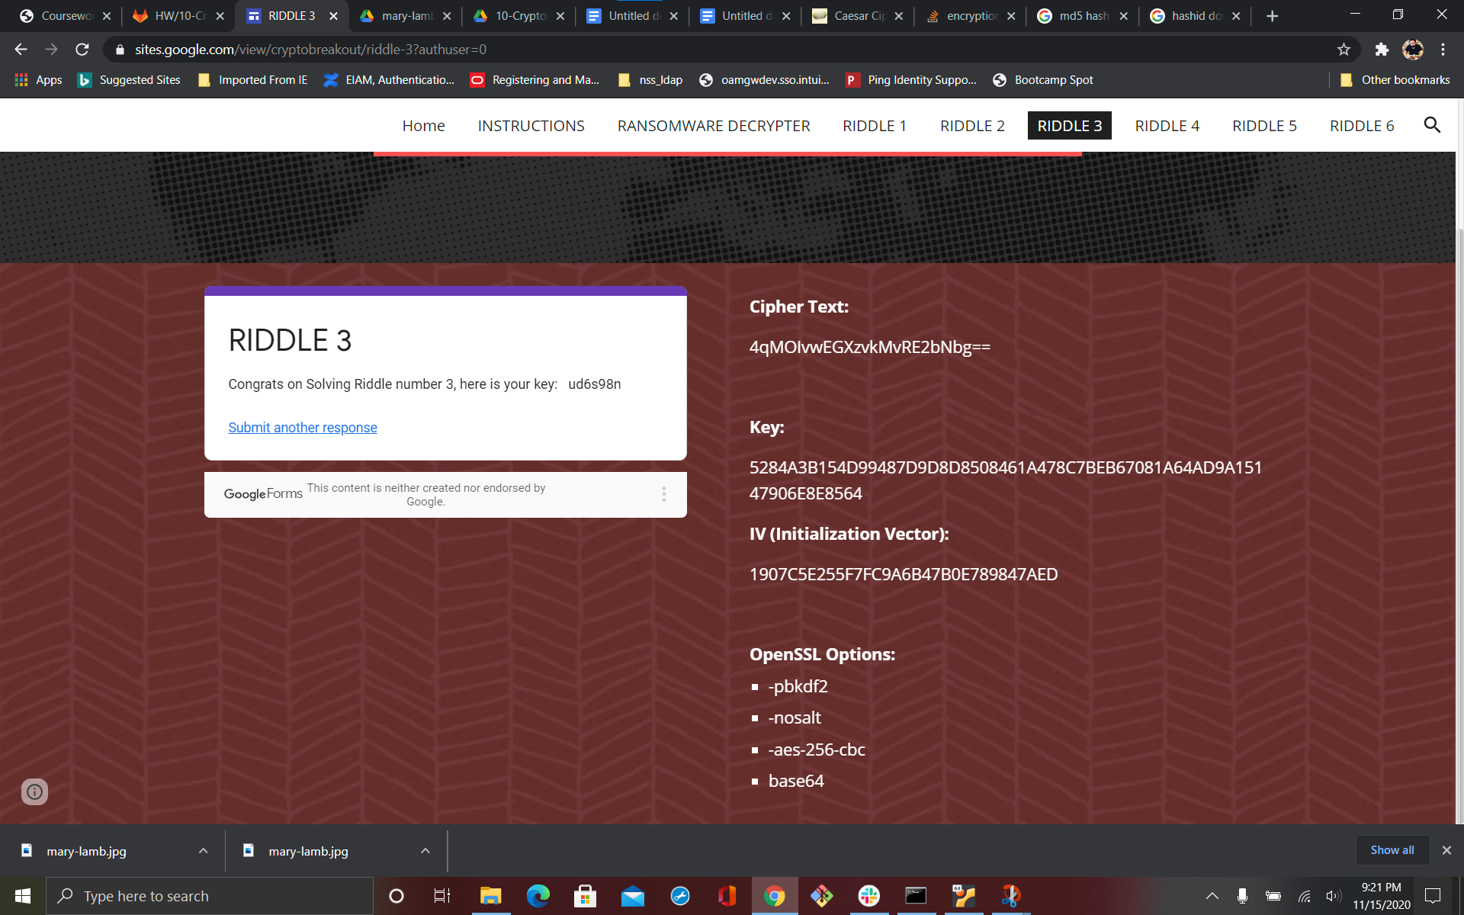

Riddle 4

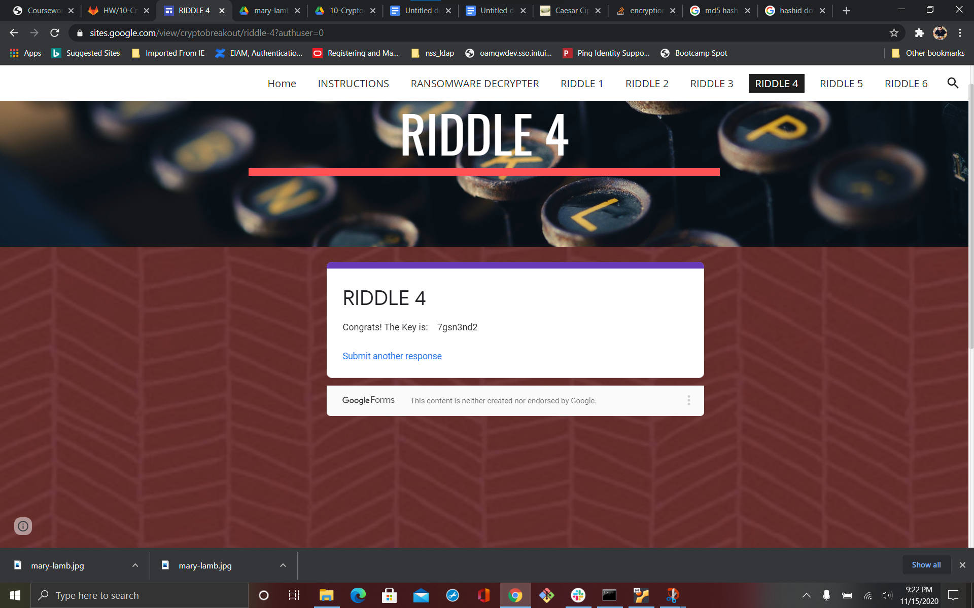

Riddle 5

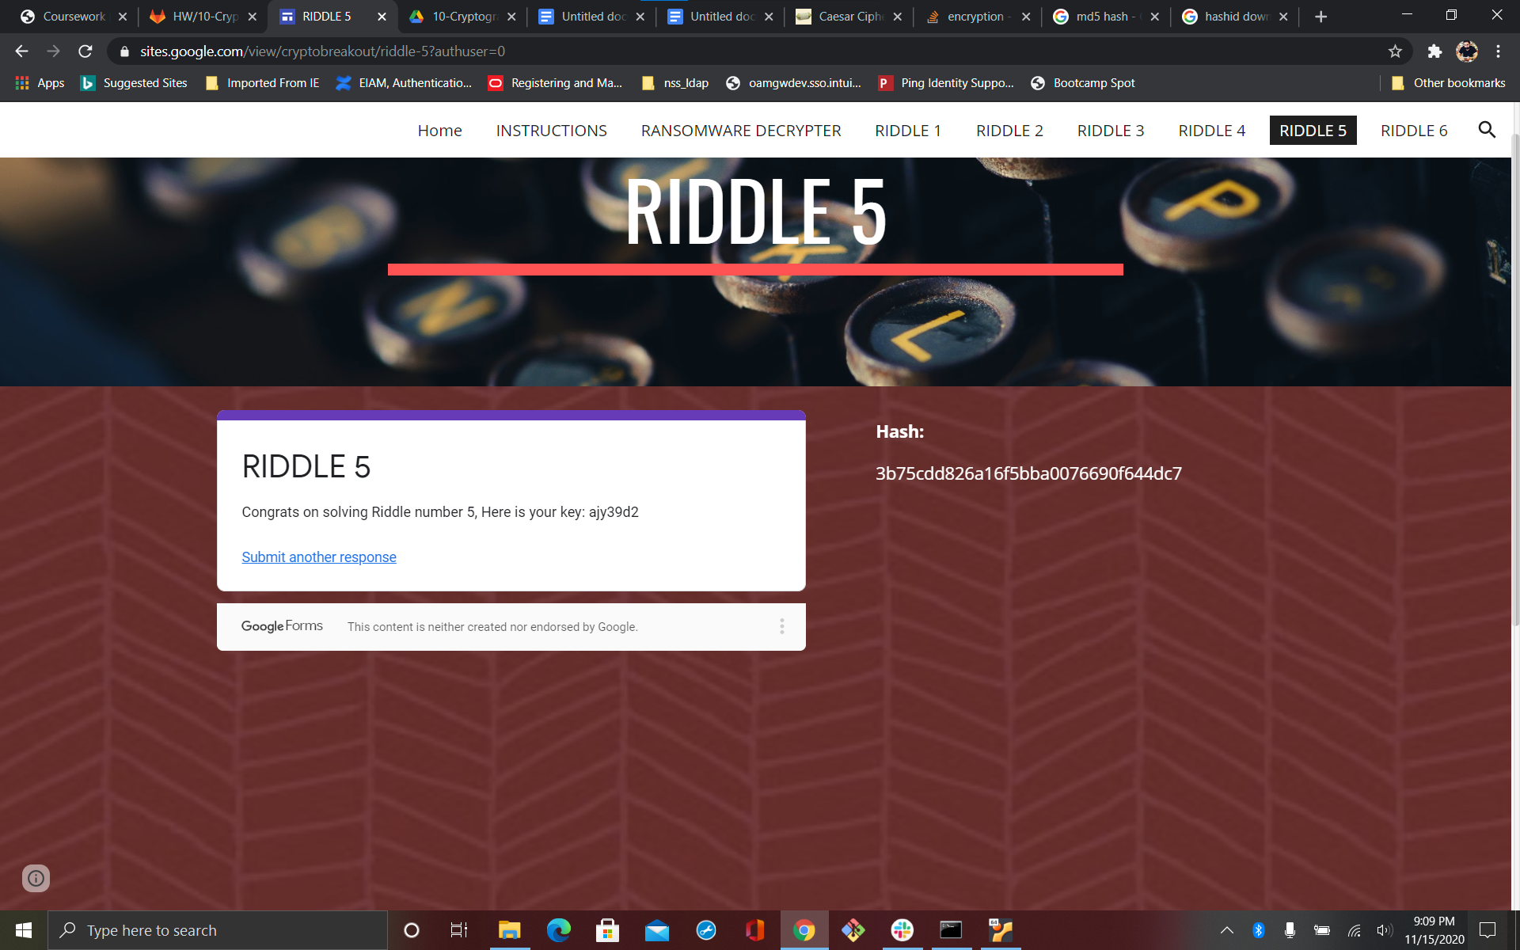

Riddle 6

